Reduce Inhaler Waste - Public Facing Campaign Checklist

Evidence suggests that 7 in 10 inhalers are thrown away before being fully used. In addition, the vast majority of inhalers are disposed of in general waste allowing the potent greenhouse gases (propellant) from metered dose inhalers (MDIs) to be released into the environment and contribute to global warming. Inhalers should be returned to pharmacies to be incinerated to reduce the negative environmental impact.

As part of the public facing campaign to reduce inhaler waste, practices should promote the return of inhalers to local community pharmacies and encourage patients to reduce inhaler waste by:
- not over-ordering their inhalers
- looking after their inhalers
- knowing how to tell when their inhaler is empty.

Practice Support Pharmacists (PSPs) should discuss the ‘Reduce Inhaler Waste Campaign’ with each practice and complete this checklist by 24th February 2023. It is not expected for practices to carry out all activities. This public facing campaign can take the form of the following communication routes: face to face, social media or practice website.

Reducing Inhaler Waste
Action | Timeline
- Inform patients to return inhalers to their local pharmacy and not to over-order their inhalers  Suggestions:  - Discuss at annual asthma review – can use this briefing sheet as a guide  - Standard directions for all inhalers on EMIS to state  “Please return your empty inhaler to your local pharmacy for environmentally safe disposal’  - Display relevant PrescQIPP logos on practice website/the practice display/visual unit (Appendix 1)  - Display the ‘Greener Practice’ video in practice (subtitles available)/ practice website/send the link to patients via SMS or AccuRx  - If practical, arrange a stall on the ‘greener inhaler’ agenda, which could include inhaler technique check (depends on space, privacy etc. at the practice)  - Practice/PCN to arrange a short webinar for patients allowing Q&A or do a recorded video by a member of the practice staff which can be embedded into the practice’s website and signposted to patients following an asthma review (see Well St Surgery example) | By 24th Feb 2023
- Inform patients to keep track of the number of doses left in their inhaler  Suggestions to discuss at annual asthma review (may not be suitable for all)  - Check the dose counter (if available)  - Write the date inhaler opened or expected to be empty. This may also remind patient to reorder with adequate time (Appendix 2 for example)  - Ask patients to keep the outer inhaler box and place a tick every time a dose is used (e.g., for salbutamol MDI as no dose counter) | By 24th Feb 2023
- Practice to consider embedding the PrescQIPP inhaler technique videos and leaflets into their practice website  https://www.prescqipp.info/our-resources/webkits/respiratory-care/inhaler-technique-assessment-videos/ | By 24th Feb 2023
- Practice to consider displaying 'return your used inhalers to a pharmacy poster’  https://tinyurl.com/ycyfpupx  - Consider sending poster to patients as a SMS or AccuRx message:  SMS  Remember to return your used inhalers to the pharmacy for safe disposal. https://bit.ly/3fTzc5n  AccuRx  Remember to return your used inhalers to the pharmacy for safe disposal. To learn more read this leaflet. https://bit.ly/3fTzc5n | By 24th Feb 2023

Tick all activities carried out

GP Prescribing Lead Name and Signature.........................................................................................
PSP Name and Signature..................................................................................................................
Date..............................

Appendix 1
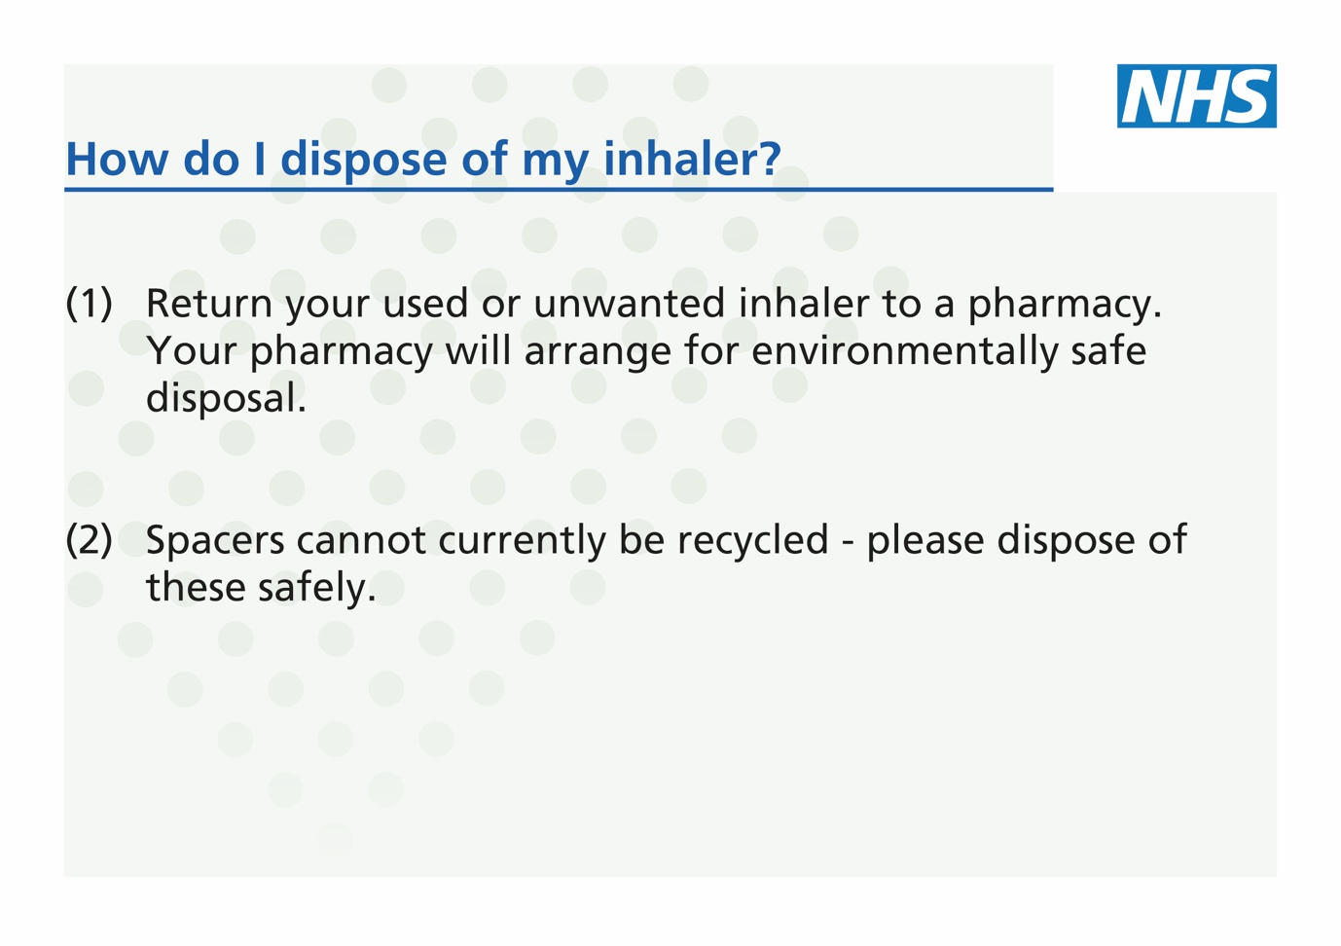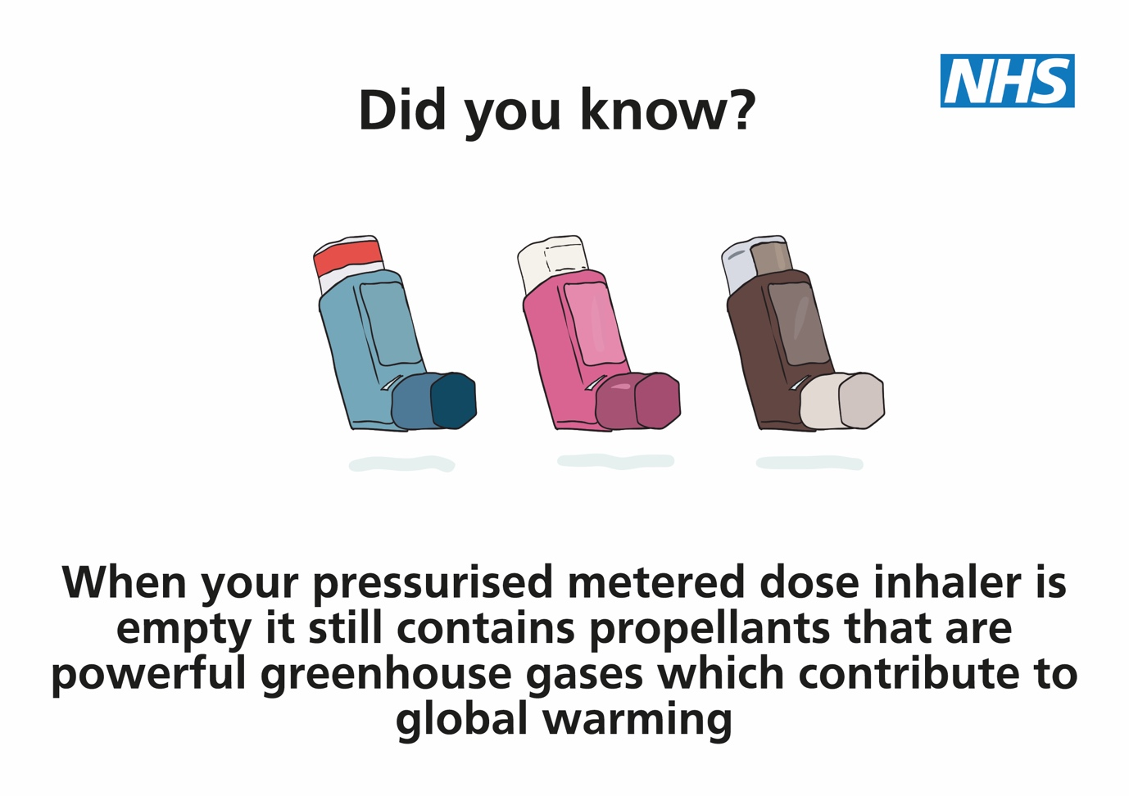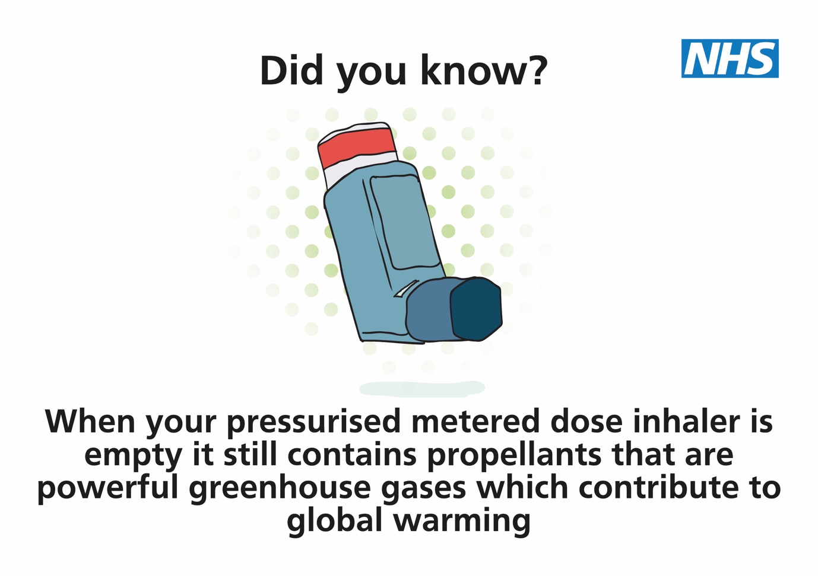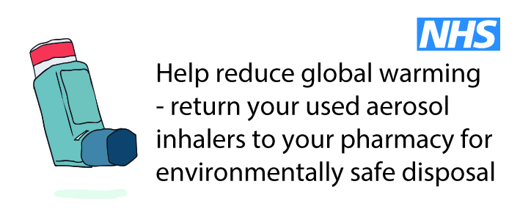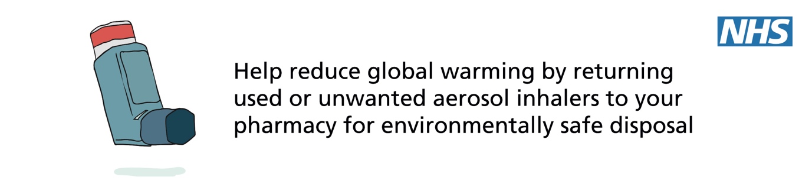

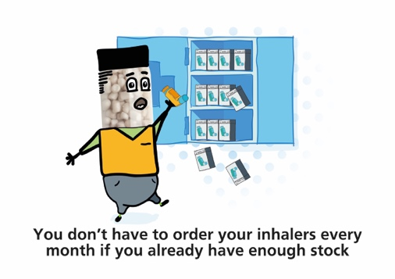
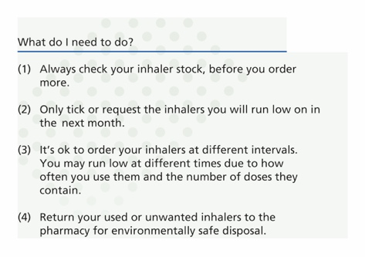

Greener Practice: inhaler device types for asthma
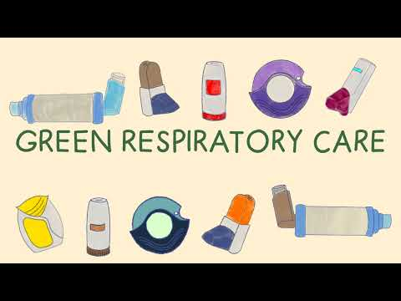

Appendix 2

